**Training model 1**

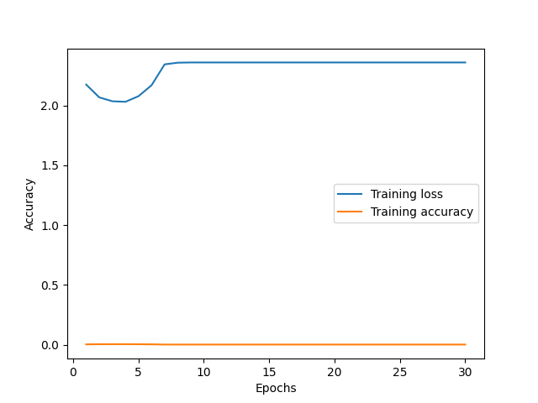

**Training model 2**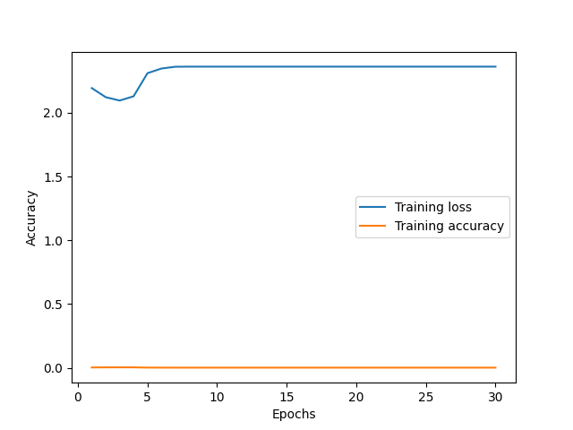

**Test model 1**

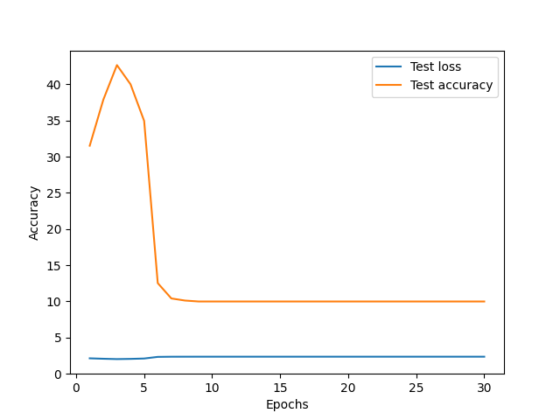

**Test model 2**

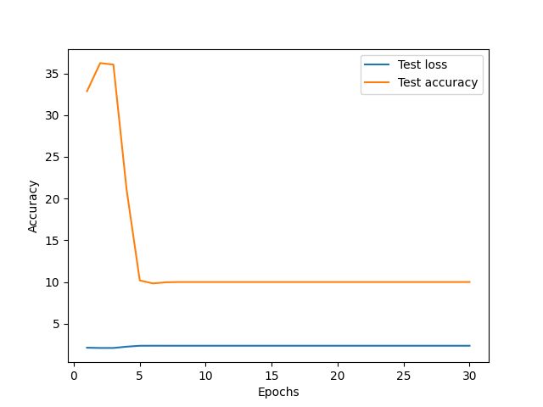

For the first model, I use 3 convolutional layers, a maxpool layer, flattening layer, then two fully connected layers with relu, followed by a softmax layer. For model 2, I increased the number of convolutional layers to 4, and kept the number of fully connected layers the same, while modifying the inputs.

When comparing the accuracy between models 1 and 2, model 1 has a lot more change in values of the accuracy. The values of the accuracy decrease more in model 1, while the test accuracy increases more in model 1. In both instances, the test accuracy was highest around 3-5 epochs, while that was where the accuracy was lowest for both training models. In both the training and test models for both models 1 and 2, the accuracy would drop to ten percent, and stay there for the rest of the time the duration of the run. When you increase the number of convolutional layers, the value of the accuracy changes less.